

**Website User Manual  
Financial Monitoring System**

**Contents:**

1. **Introduction**
   1. **Major Features**
2. **Getting Started**
   1. **System Requirements**
   2. **Launching The Application**
   3. **Application Layout**
      1. **The Homepage**
      2. **The Login**
3. **Main Functions**
4. **Data Management  
   I. Managing By Groups  
   Ii. Managing By Record**
5. **Tools**
6. **Search And Query Task**

**I. Introduction**

Handling a thousand of employees of Philippine Air Force (PAF) is a hard task. There is a widespread agreement that the transaction at the Finance office in PAF is very complicated, take – time, and inconvenient to both personnel of PAF and the office. This is due to the fact that when the time a personnel goes to the Finance office, they encounter a lot of problems. In a normal day, about 30 minutes were consumed for a transaction to be completed. When personnel come in a busy day, they spend almost an hour to complete the transaction.

The finance office has an existing system that is available only for the admin. The system itself is not internet based so it is only for the office. They also have some problem in limited storage of data because there is no server. Papers are seen on the office so they want to lessen the use of papers.

To give a solution for these problems experience by the company, the best approach that can be made is by the use of the technology. Changing and developing the old procedure and system will provide the finance office staffs have an easy job. A system that can display all the financial summary of a personnel, so that it will not cost them time. Then, provide an accessible system which can be use anywhere and anytime. By using the desire system it will make the transaction of the finance center be convenient.

This system is for all the personnel of PAF who wish to have very fast transaction, the Financial Claim Monitoring System is a web-based application that will help them for making a quick and accurate transaction. Staffs and employees of the finance office who are having hard time will have a lessen work. The new system will allow all personnel of PAF to access the system all the time and everywhere via a computer with an internet. The system provides a better solution for the problem of the office. It reduces much time and resources required in processing in every transaction of a personnel.

i. major features

|  |  |
| --- | --- |
| FE-1 | Transaction approval of financial claims per personnel. |
| FE-2 | Summary of collateral and variable claims of the personnel. |
| FE-3 | Searching of the personnel records including all their financial claims. |
| FE-4 | Adding financial records of personnel, if needed. |
| FE-5 | Update financial claims of a personnel, if needed |
| FE-6 | Viewing of financial claim status |
| FE-7 | Deleting financial claims of a personnel, if necessary |

**II. Getting started**

The Philippine Air Force – Financial Monitoring System is a web browser based program that delivers the updating of claim from the Finance Center to your computer through internet connection. The majority of the work performed by the application is done by the PAFFC administrator, thus making it possible to interact with complex information on nearly any computer with a web browser.

i. System Requirements

The system is designed for Google Chrome and Mozilla Firefox 2.0 or higher. Both browsers are available for free download. Additional web browser may work, but not been tested and are not supported. Your computer should also meet the minimum system requirements provided by the manufacturer of the browser you are using. The system will perform best on computers with a high-speed internet connection to DSL, cable, or faster.

ii. Launching the Application

The system is already hosted to the server of our school and can be used by typing the link below to your browser.

[**http://projects2.apc.edu.ph/paf-fcms**](http://projects2.apc.edu.ph/paf-fcms)

iii. Application Layout

*i. the homepage*

The PAF-FCMS layout is similar to many other common sites. As you can see at the homepage, it contains three main links namely “home”, “about”, and “login”. The active link is emphasized by a box. Hovering the mouse to the other main links will also be emphasized.

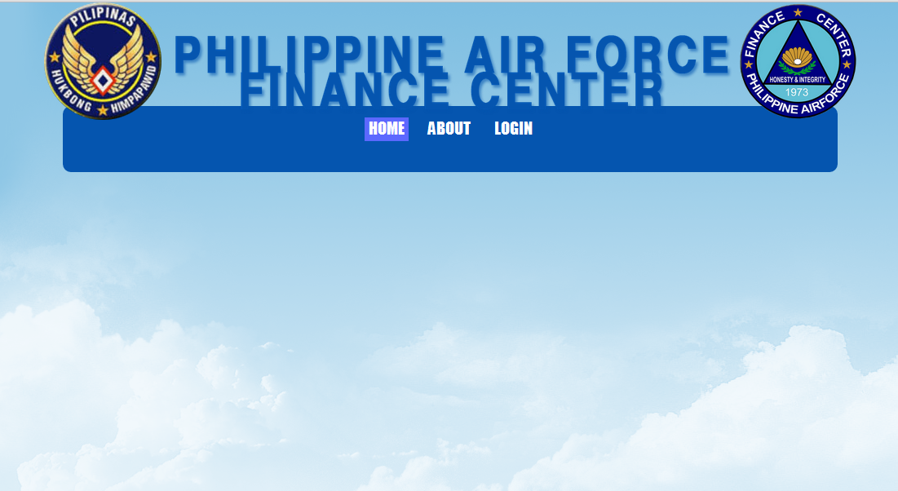

*ii. The login*

The login page contains two blank textboxes that are needed to filled by data. Correct data will allow you to enter, the system will automatically response when you input an incorrect or blank data. The website also includes a checkbox that remember your credentials when you access the site again.

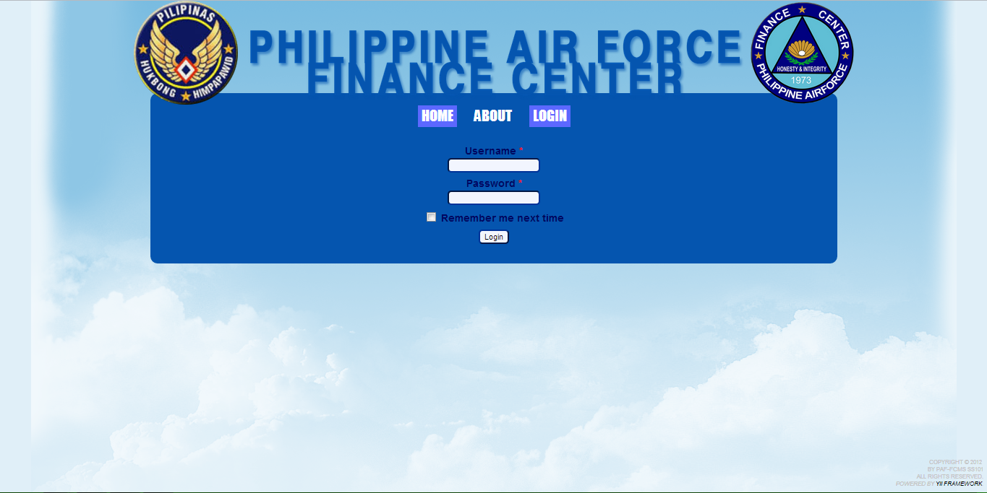

**III. Main Functions**

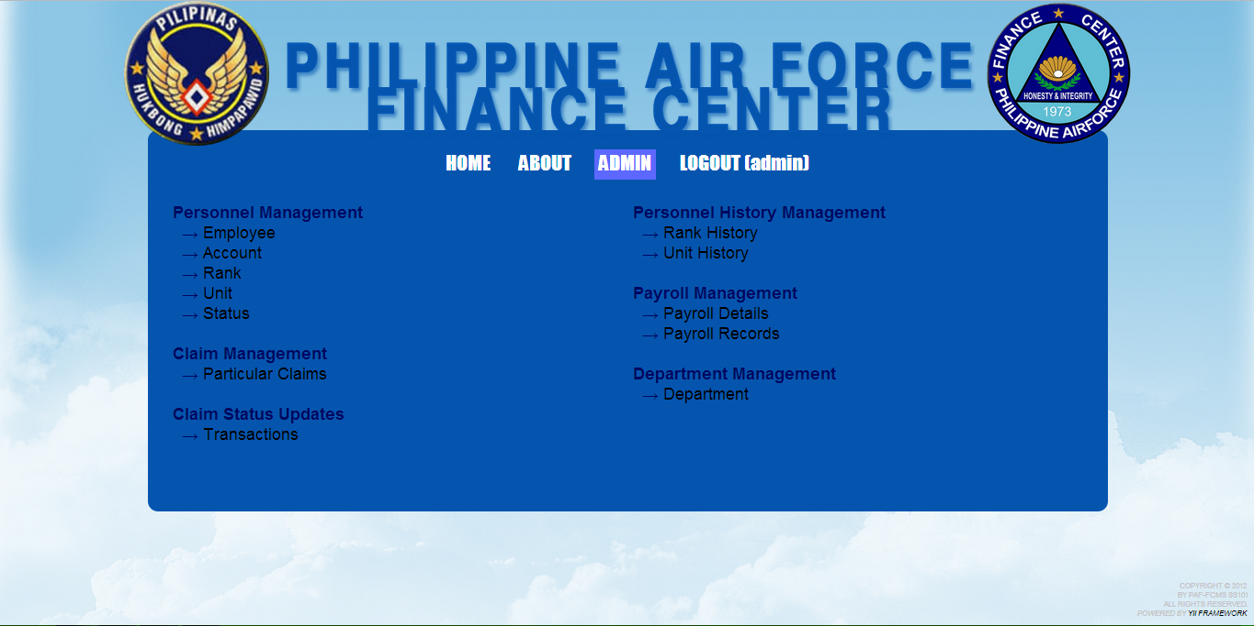

The picture shows different links. Links are organized by relation for easy access to related items. Clicking the menus available will direct you to the specific link.

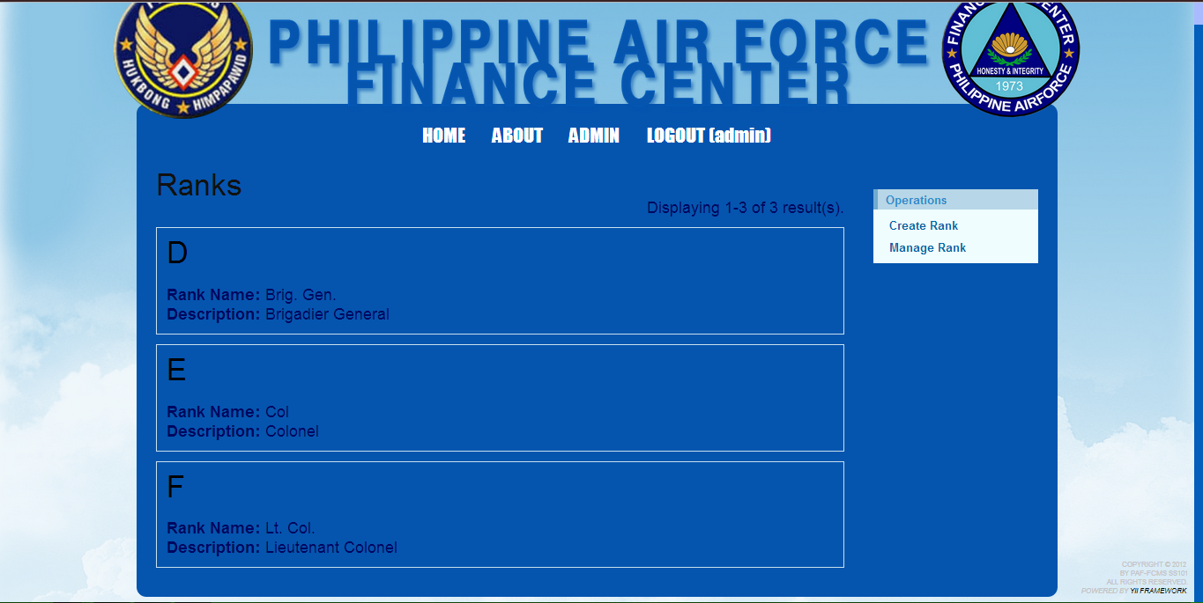

Data will be displayed if it is available. Clicking the name will let the system display the complete details of a certain item.

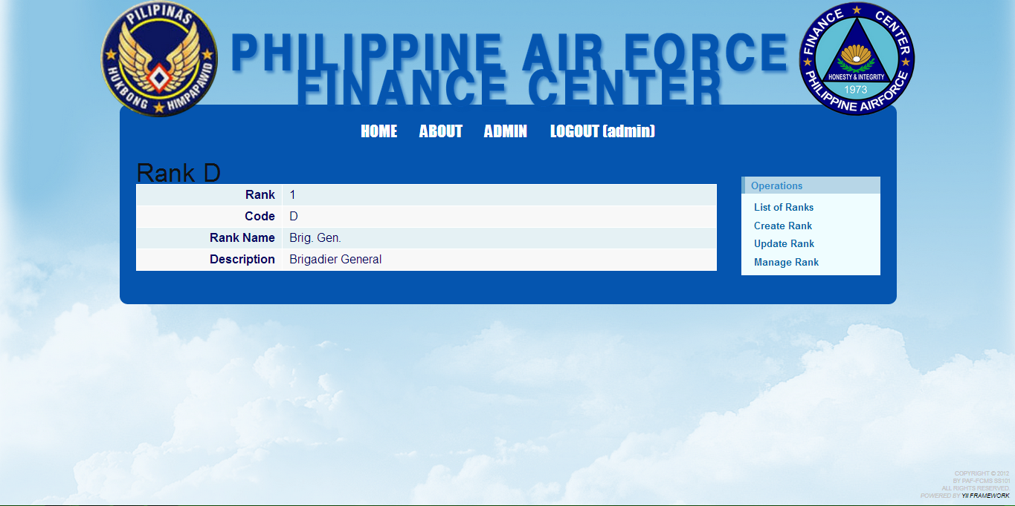

**IV. Data Management**

Data managing is only accessible for certain users that are authorized. Basically, it is for administrator who manages the data.

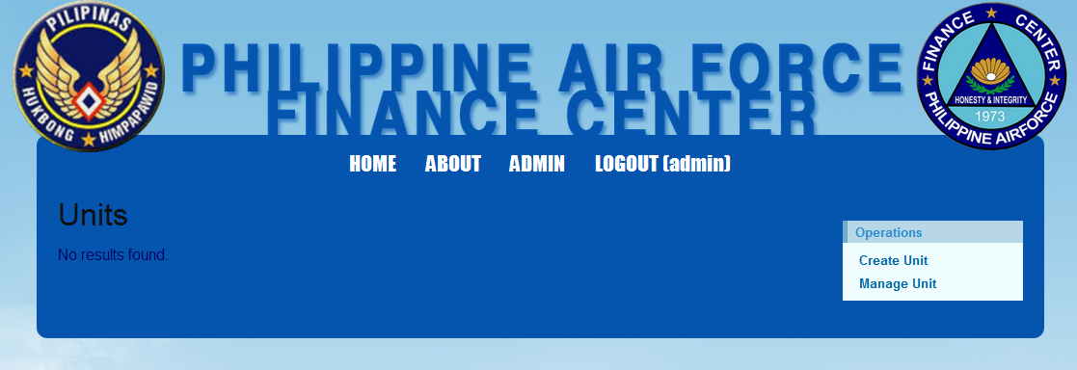

The operations menu displays different functionalities. Create button/link will let you make a new record. Manage button/link will direct you to a webpage like the picture below.

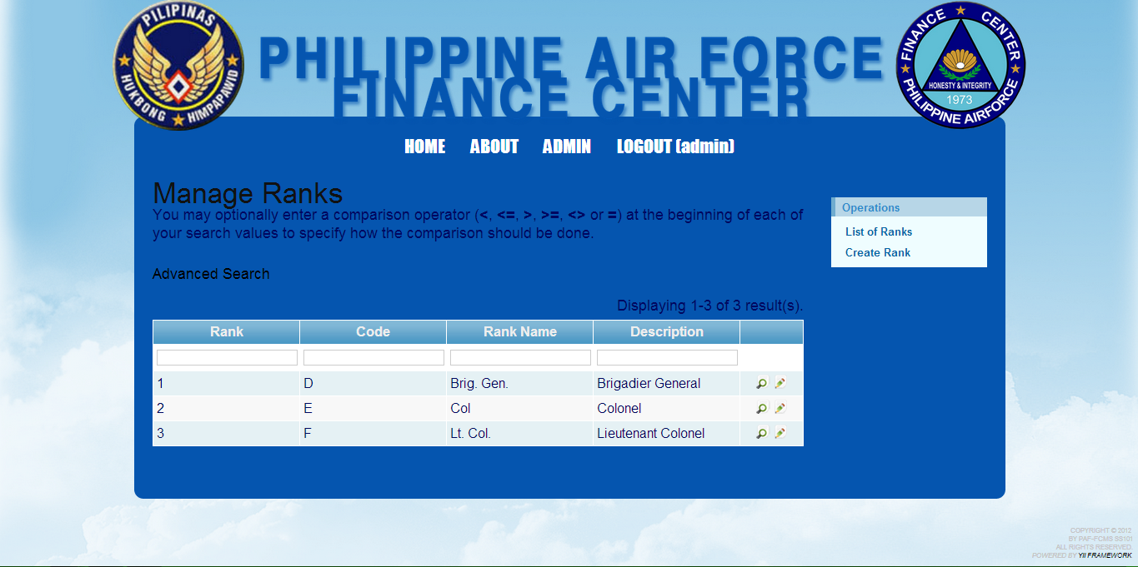

1. managing by groups

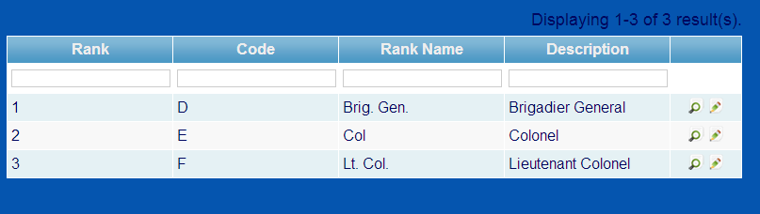

The website allows managing data in groups. The table displays all of the information of a certain record. Available buttons are view and update.

1. managing by record

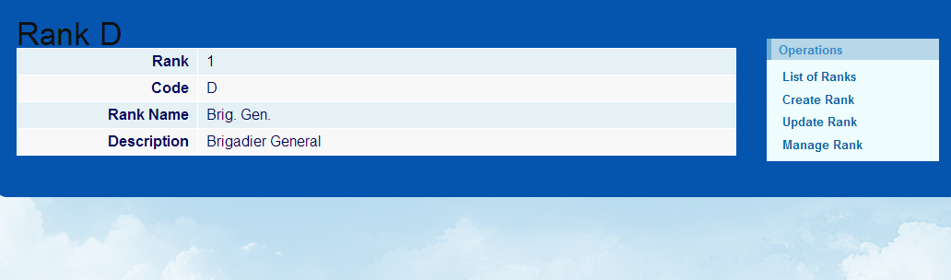

The website also allows managing data by record. This will appear by clicking an ID number. It will displays different managing functionalities in the right side of the website.

**V. Tools**

The previous section of this user guide explained how to get started with the system and how information is organized within it. This section will build on that information by explaining how to use the application’s tools to navigate within the data and identify features in it.



As you can see in the pictures above, there are two basic tools in the application. Also, there is a normal search in the picture where you can type any keyword you want to search in the record through the blank textboxes above.

 **View**

This view tool is design to easily view the information of the chosen field.

**Edit**

In this tool, you can edit the chosen record automatically.

**VI. Search and Query Task**

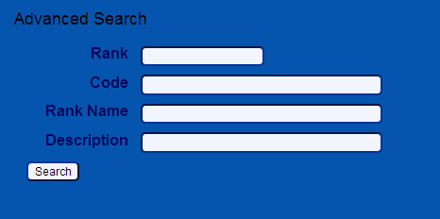

The *Advanced Search* allows you to narrow down the focus of the search by including details such as;

- ID

- Code

- Name

- Description

It has just the same functionalities with the normal search.